**Measuring Seasonal Variation of Land Use and Land Cover Indices and Its Impact on Land Surface Temperature in Dhaka, Bangladesh**

**Abstract**

Rapid urbanization has induced land use and land cover (LULC) changes that increase land surface temperatures (LST) in Dhaka, Bangladesh. This study aimed to analyze seasonal LST variations in relation to LULC indices, emphasizing the need for mitigating urban heat island effects to support sustainable living. The result shows that the highest and lowest LST values were observed in the built-up and vegetation-covered areas, respectively. The correlation values indicate a significant inverse correlation (R2 > 0.50) between NDVI and LST, as well as MNDWI and LST. On the contrary, positive correlations were observed between NDBI and LST, and between NDBAI and LST for both the summer and winter seasons. Finally, subsequent vegetation decline (-69.34%) and increasing built-up area (+11.30%) between 2000 and 2020 in Dhaka district were found to be the most significant factors for the increasing trend and spatial heterogeneity of LST in Dhaka. This approach aimed to provide a cost-effective methodology for monitoring LST hotspots and informing urban planning strategies for sustainable development.

Abbreviation: Land use and land cover (LULC), Land surface temperatures (LST), Normalized difference built-up index (NDBI), Modified Normalized Difference Water Index (MNDWI), Normalized Difference Bareness Index (NDBaI), Normalized difference vegetation index (NDVI)

**Introduction**

Climate and land use are closely linked, with changes in land use and land cover (LULC) both affecting and being affected by climate across various temporal and spatial scales. Improper LULC change, especially in urban areas, is a leading cause of climate change (Thakur, Mondal, et al., 2021). Rising land surface temperatures (LST), driven by both human and natural causes, have become a critical urban issue, linked to reduced comfort, poorer air and water quality, increased mortality, and indirect economic losses (Steeneveld et al., 2018).

LULC changes can occur because of both human and climate-related factors. Expanding settlements often lead to the permanent loss of natural land cover, affecting local weather, precipitation, and temperature patterns (Thakur, Maity, et al., 2021). The shift towards built-up areas diminishes eco-friendly land covers like forests, vegetation, and waterbodies, impacting ecosystems and carbon storage (Kumar et al., 2021). Although LULC change impacts cities worldwide, the effects are more intense in developed areas, with growing concern from scientists, health authorities, and urban planners over its implications on health, energy demand, and vegetation cycles (Li et al., 2017; Lowe, 2016).

While previous research has explored the LST impacts of LULC in major Bangladeshi cities (e.g., Dhaka, Chittagong), most focus solely on summer variation and skip winter variation. Water bodies and bare land are frequently overlooked. A limited number of studies explored the influence of all LULC types on LST dynamics. Common indices like NDVI and NDBI, though frequently used, often overlook other land covers (NDBaI, NDWI, MNDWI) (Huang & Cadenasso, 2016).

This study will address these gaps by analyzing historical LULC and LST trends, and the seasonal and spatial distribution of LULC, LST, NDVI, NDBAI, MNDWI, and NDBI from 2000 to 2020 in Dhaka City. The findings aim to offer insights for urban planners and policymakers to craft effective mitigation strategies in urban development.

**Objective**

The objective of this study is to analyze historical trends and seasonal distributions of LULC, LST, and land use indices (NDVI, NDBaI, MNDWI, NDBI) from 2000 to 2020 in Dhaka, and to assess seasonal LST changes relative to these indices to guide urban planning and mitigation efforts.

**Research Question**

* How do seasonal dynamics of LULC indices affect LST in Dhaka?
* What specific changes have occurred in built-up areas, vegetation cover, and LST over time?
* How are different LULC indices correlated with LST?
* What are the implications of these findings for mitigating LST hotspots and preserving ecological balance?

**Study Area**

Dhaka has been chosen as the study area due to its significant and dynamic urbanization patterns, driven by rapid population growth and migration. In the 1990s alone, the city experienced an unprecedented expansion, adding over a million residents(Ahmed et al., 2013). This growth led to the expansion of Dhaka's boundaries and urban sprawl into surrounding regions (Fig. 1). These areas have undergone considerable transformation due to the development of infrastructure, such as roads, highways, industrial zones, commercial buildings, and factories, aimed at attracting foreign investments and improving urban services (Arefin, 2020). While these initiatives have created economic opportunities and socio-economic benefits, they have also triggered significant land use and land cover (LULC) changes, leading to urban expansion and intensification of urban heat island (UHI) effects. Analyzing Dhaka district allows this study to assess the seasonal distribution of land surface temperature (LST) and understand the influence of various land use factors in one of the most dynamic urban environments in Bangladesh.

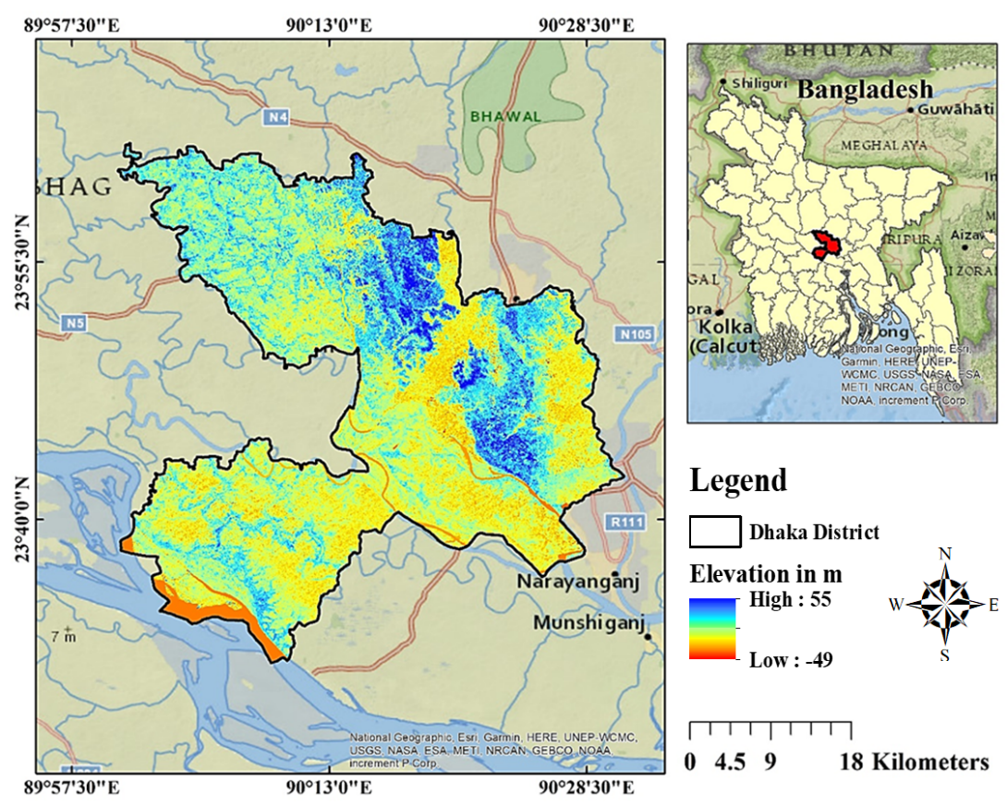

**Fig 1.** Study Area Map of Dhaka Metropolitan Area, Year 2024.

**Methodology**

**Data Collection**

To identify spatial and temporal variations for summer and winter, Landsat images will be collected, using Landsat Collection 1 Level 1 data. ArcGIS 10.8 will be employed to process and analyze these images, extracting LST, LULC types, and land use indices through GIS-based remote sensing. Finally, the regression model will be created using python.

**Land Use Indices Calculation Procedure**

**Normalized difference built-up index (NDBI)**

NDBI quantifies built-up area concentration by calculating a ratio between near-infrared (NIR) (band 5 for Landsat 8, band 4 for Landsat 5) and shortwave infrared (SWIR) (band 6 for Landsat 8, band 5 for Landsat 5) radiation captured by Landsat sensors (F. Zhang et al., 2016).

$NDBI=\frac{\left(SWIR -NIR\right)}{\left(SWIR +NIR\right)}$……………………………………………………. (1)

NDBI values range from -1 to 1. The higher the value, the more developed area, metro area, or created territory exists.

**Modified Normalized Difference Water Index (MNDWI)**

MNDWI will be used to the enhancement of open water features, the MNDWI employs pixel values from green (band 3 for Landsat 8 and band 2 for Landsat 5) and short-wave infrared (SWIR) bands (band 6 for Landsat 8 and band 5 for Landsat 5) (Das et al., 2021). It also reduces built-up area characteristics that are commonly linked to water in other indexes. The MNDWI estimation ranges from -1.0 to +1.0.

$MNDWI=\frac{(Green -SWIR)}{(Green +SWIR)}$…………………………………………… (2)

**Normalized Difference Bareness Index (NDBaI)**

NDBaI was suggested by Chen et al. (2006) to distinguish bare land from other land uses (NDBaI). The range of the NDBaI estimation is -1.0 to +1.0 (Chen et al., 2006).

$NDBaI=\frac{((SWIR Band1 – TIRS Band 1))}{(SWIR Band1 + TIRS Band 1)}$……………………………… (3)

**Normalized difference vegetation index (NDVI)**

Pixel values from the Landsat Near-Infrared (band 5 for Landsat 8 and band 4 for Landsat 7) and Red (band 4 for Landsat 8 and band 3 for Landsat 5 image) spectral bands will be employed to identify the NDVI (Grigoraș & Urițescu, 2019). NDVI is calculated as-

$NDVI=\frac{(NIR Band – Red Band)}{(NIR Band + Red Band)}$……………………………………… (4)

**Land Surface Temperature (LST) Calculation Process**

LST is the radioactive temperature of earth surface which is critical for understanding the basic science of the land surface via the energy cycle and aquatic exchange with the environment (Ahmed et al., 2013). LST analysis using satellite thermal data entails a variety of procedures, including sensor radiometric alignment, correction of air and surface reflectance and spatial variation of LULC. For calculating LST thermal band 11 (for Landsat 8) and thermal band 6 (for Landsat 5) will be utilized.

$LST=[\frac{TB}{ 1+\left(\frac{λ ×TB}{ α}\right)\ln{ε}}]$……………………………. (5)

**Correlation Analysis**

To determine the interlinkage between two different variables or variable of interest correlation analysis is very effective. So, for assessing the nexus between land use indices and LST, regression models namely linear regression, Pearson’s correlation coefficient (Pr) will be calculated using: xi = values of the x-variable in a sample, x′ = mean of the values of the x-variable yi = values of the y-variable in a sample and y′ = mean of the values of the y-variable (Isaac, 2018).

$Pr= \frac{\sum{(x_{i}-x^{'})(y_{i}-y^{'})}}{\sqrt{\sum{{(x_{i}-x^{'})}^{2}×{(y_{i}-y^{'})}^{2}}}}$……………………… (6)  
)

Spearman’s rank correlation coefficient (SC) (Sedgwick, 2014) will also be calculated for all the seasons and years. Where di = difference between the two ranks of each observation, n = number of observations.

$SC=1- \frac{6\sum{d_{i}^{2}}}{n(n^{2}-1)}$………………………………. (7)

The correlation analysis will be conducted in Python using Jupyter Notebook, applying regression models to assess relationships between land use indices and LST. Linear regression and Pearson’s correlation coefficient (Pr) will be calculated based on xi and yi​ values and their means x′ and y′. Additionally, Spearman’s rank correlation coefficient (SC) will be computed for all seasons and years. Python libraries, such as Pandas, NumPy, and SciPy, will facilitate the calculations and data handling, ensuring efficient analysis and visualization.

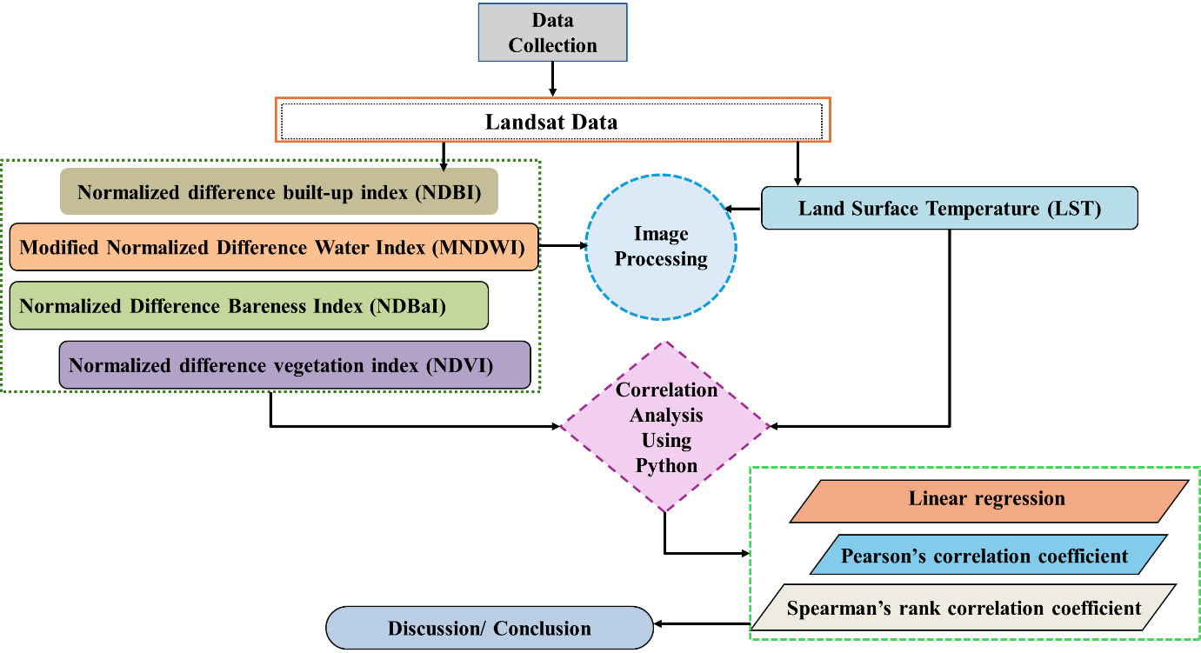

**Fig 2.** Methodological Framework

**Results and Discussion**

The statistics of the classified LULC types for both the summer and winter seasons (area in %) and change (in km2) are presented in Table 1. Fig. 2 shows the LULC variation ranges (standard deviations) for summer and winter season. The LULC analysis shows that, in 2000, the vegetation (VG) covered the largest areas, accounting for 48.14% in winter and 49.14% in summer. The second largest, the agricultural land (AL), covered 23.37% of areas in winter and 24.19% in summer. Water body (WB) cover was the lowest (4.57% in winter and 4.43% in summer). Rapid population growth, higher urbanization and migration rates, and the transformation of other LULC types into built-up areas have all increased over the last two decades.

**Table 1** Classified LULC statistics of Dhaka district Summer (S) and Winter (W) (area in %)

|  |  |  |  |  |  |  |  |  |
| --- | --- | --- | --- | --- | --- | --- | --- | --- |
|  | 2000 | | 2010 | | 2020 | | Change during  2000 – 2020 (km2) | |
| W | S | W | S | W | S | W | S |
| AL | 23.37 | 24.19 | 20.95 | 21.31 | 17.01 | 17.6 | -93.45 | -96.80 |
| BL | 8.65 | 7.77 | 8.81 | 8.34 | 9.38 | 8.54 | 10.64 | 11.30 |
| BU | 14.55 | 14.48 | 18.03 | 17.87 | 23.19 | 23.08 | 126.97 | 126.32 |
| VG | 48.86 | 49.14 | 47.82 | 48.23 | 44.10 | 44.83 | -69.94 | -63.20 |
| WB | 4.57 | 4.43 | 4.39 | 4.25 | 6.32 | 5.96 | 25.78 | 22.38 |
| Total | 100 | 100 | 100 | 100 | 100 | 100 |  |  |

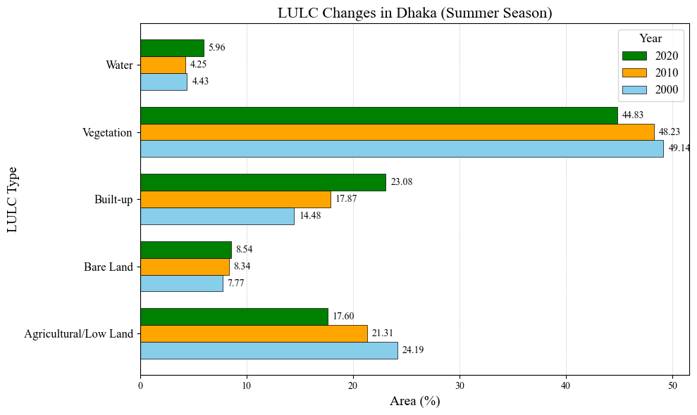VG= Vegetation, AL= Agricultural Land, BU= Built Up, WB= Water Body, BL= Bare Land

**Fig 3.** Land Use Land Cover variation for summer and winter season.

The results of the LULC types evaluated in Table 1 show that the overall percentage and total area of the water body have increased over time. the present study shows such results because the study area is on the bank of the Padma River, which is one of the largest rivers in Bangladesh. Over the past few decades, the Padma River has changed its tidal flow, resulting in river erosion and several river training works taking place (Ophra et al., 2018).

**Seasonal variability and intensity of land use index analysis, 2000** – **2020**

For both the winter and summer season, the health status of built-up areas, bare land, soil moisture and vegetation in the study area were measured using the NDBAI, MNDWI, NDBI, and NDVI indices, respectively. The outcomes of these indices are presented in Figure 4–7.

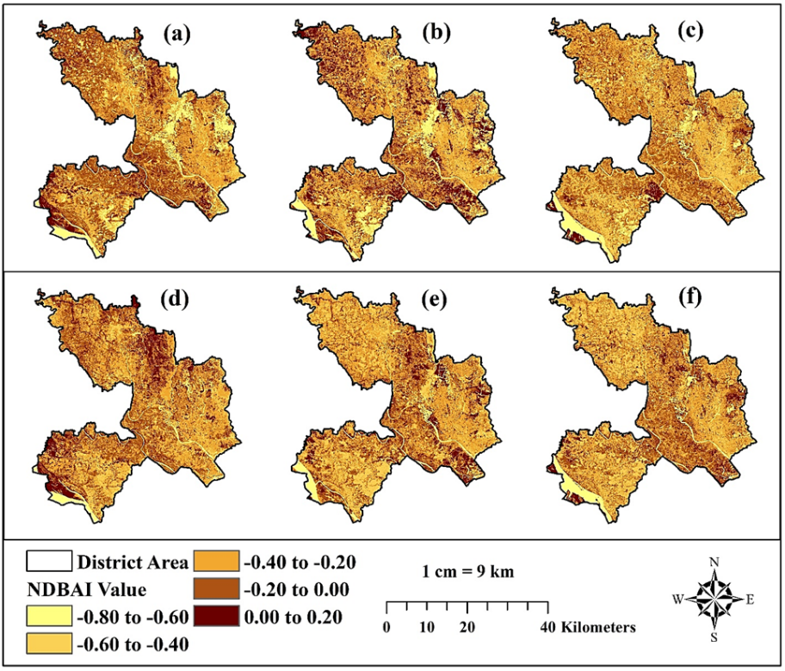

**Fig. 4.** NDBaI profile of the study area during winter season of (a) 2000 (b) 2010 (c) 2020 and summer season of (d) 2000 (e) 2010 (f) 2020.

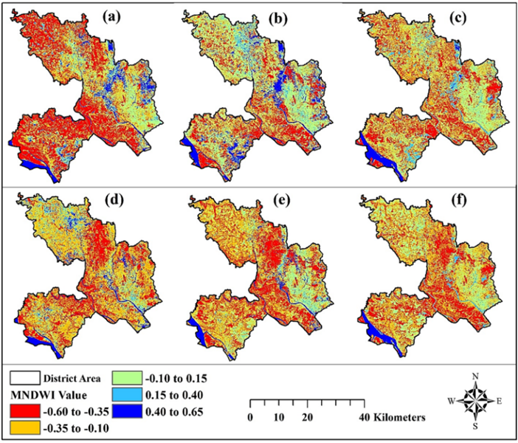

**Fig. 5.** MNDWI profile of the study area during winter season of (a) 2000 (b) 2010 (c) 2020 and summer season of (d) 2000 (e) 2010 (f) 2020

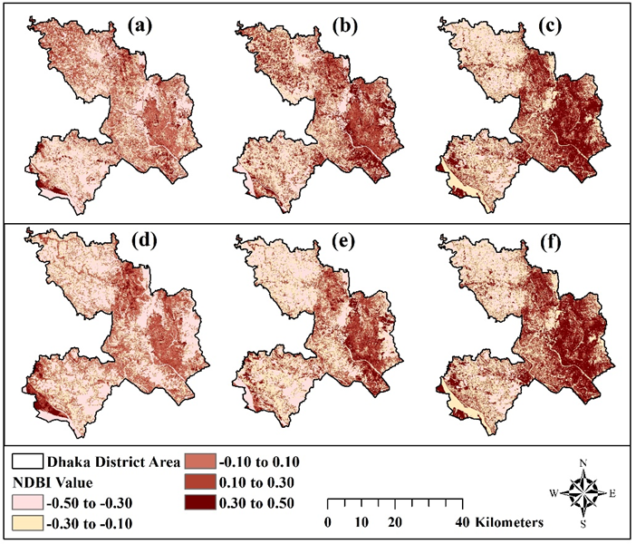

**Fig. 6.** NDBI profile of the study area during winter season of (a) 2000 (b) 2010 (c) 2020 and summer season of (d) 2000 (e) 2010 (f) 2020

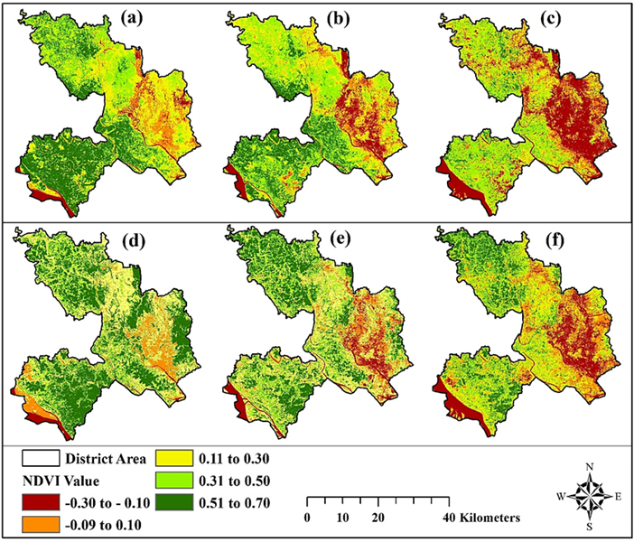

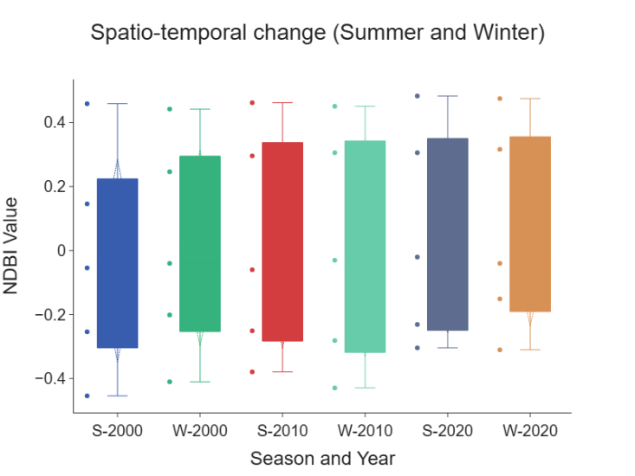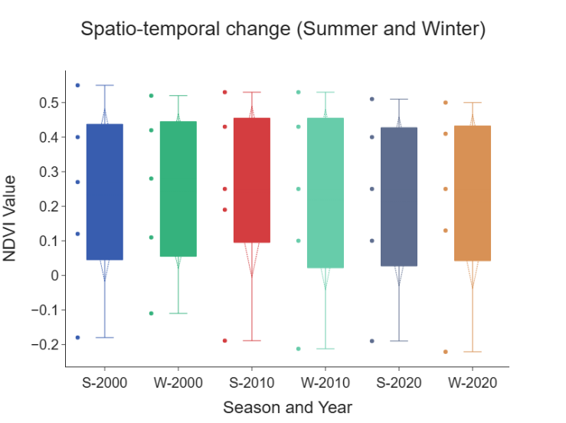**Fig. 7.** NDVI profile of the study area during winter season of (a) 2000 (b) 2010 (c) 2020 and summer season of (d) 2000 (e) 2010 (f) 2020

**Fig 7.**  Min, max and mean value for NDBI, NDVI, NDBaI, MNDWI of year 2000, 2010 & 2020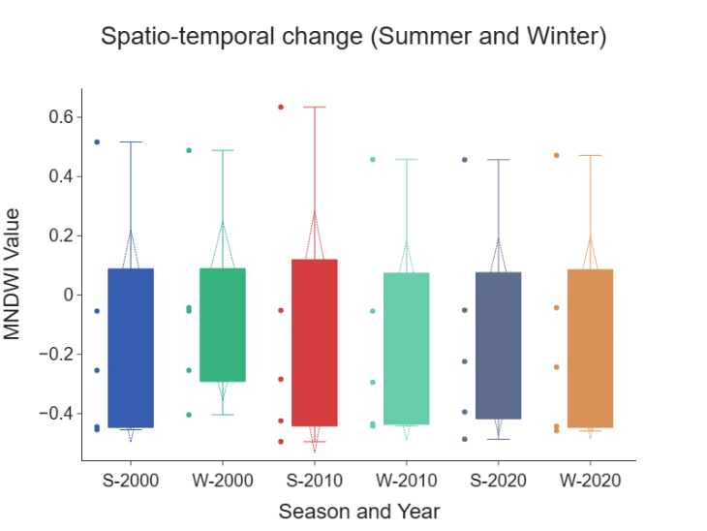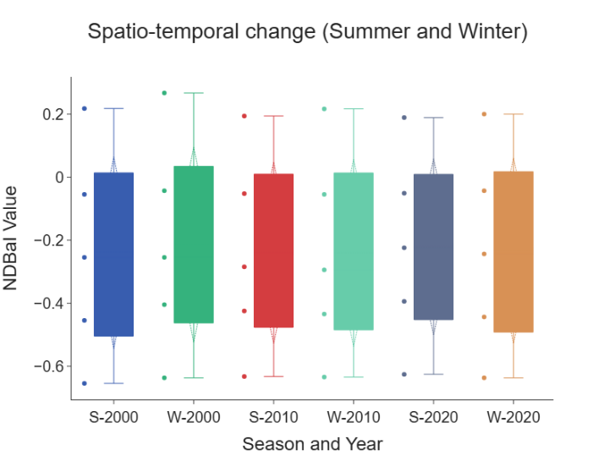

**Seasonal variability of LST, 2000–2020**

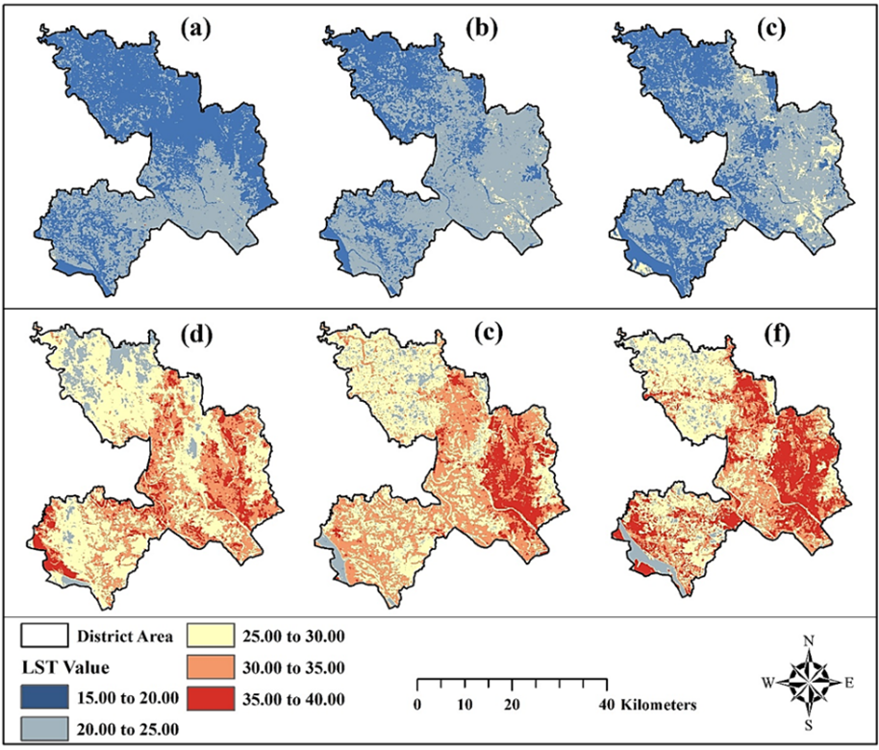

**Fig. 8.** Derived LST profile of the study area during winter season of (a) 2000 (b) 2010 (c) 2020 and summer season of (d) 2000 (e) 2010 (f) 2020

The seasonal outcomes of the LST analysis show a huge variation in summer and winter. Fig. 8 shows the land covers of the study area witnessed an increasing trend of LST over the study period (2000 to 2020). The statistics of spatial distributions of the LST are presented in Table 2. Analysis shows that 61.48% of areas LST was between 150C – 200C during winter in 2000, whereas it decreased to 42.60% in winter 2020. In summer 2000, about 12.50% of areas exhibited LST above 350C, this percentage increased to 19.25% in summer 2010 and to 36.50% in summer 2020. Fig. 8 shows that the increasing trend of LST was scattered throughout the district but increased mostly in Dhaka Metropolitan area.

**Table 2** Observed seasonal LST variations during the study period

|  |  |  |  |  |  |  |
| --- | --- | --- | --- | --- | --- | --- |
| LST ranges | 2000 | | 2010 | | 2020 | |
| Winter | Summer | Winter | Summer | Winter | Summer |
|  | Area in % | | | | | |
| 15 – 200C | 61.48 | 0 | 30.21 | 0 | 42.60 | 0 |
| 20 – 250C | 38.02 | 7.85 | 68.50 | 6.40 | 52.85 | 9.35 |
| 25 – 300C | 0.50 | 51.15 | 1.29 | 33.35 | 4.55 | 33.65 |
| 30 – 350C | 0 | 28.50 | 0 | 41.00 | 0 | 20.50 |
| 35 – 400C | 0 | 12.50 | 0 | 19.25 | 0 | 36.50 |

**Nexus between LULC and LST**

**Regression analysis**

In this section, the nexus between the seasonal LST and land use indices by using the linear regression model, Pearson’s correlation model, and Spearman’s rank correlation method is assessed. Fig. 9 and 10 represent the outcomes of the regression analysis for the summer season and winter season, respectively.

The R2 value of summer season for NDVI vs LST is 0.7435, 0.7821 and 0.82774, respectively; and Pearson’s correlation were -0.8623, -0.8844 and -0.9098, respectively in the years 2000, 2010 and 2020 indicates the strong negative correlation between the LST and vegetation health dynamics. The Pearson’s correlation coefficient values of -0.7130, -0.6837 and -0.6302 indicate strong negative correlation between LST and water health during the summer season. For NDBI vs LST, the summer season LST value was calculated 0.60132, 0.64243 and 0.7764, respectively, which indicates strong positive correlations between built-up expansion and LST. The linear regression, Spearman correlation coefficients and Pearson’s coefficients demonstrate that the increase in LST in Dhaka district was mostly influenced by the decline of vegetation and increase in built-up areas.

**Fig. 9.** Correlation between the summer season land use indices and LST during 2000–2020

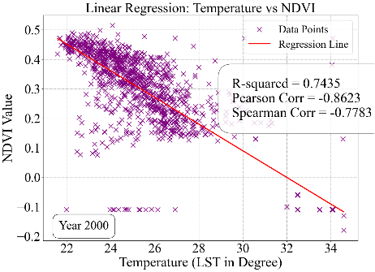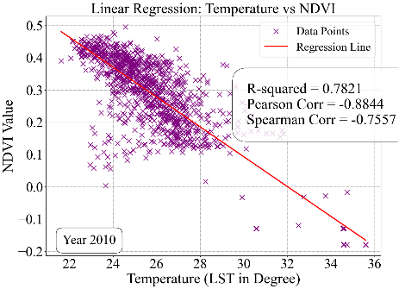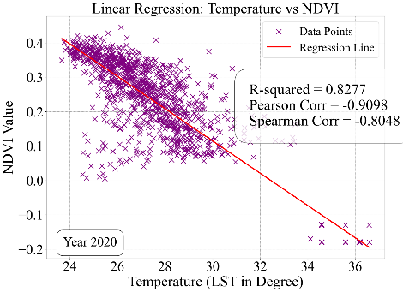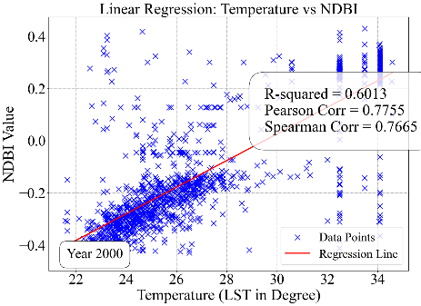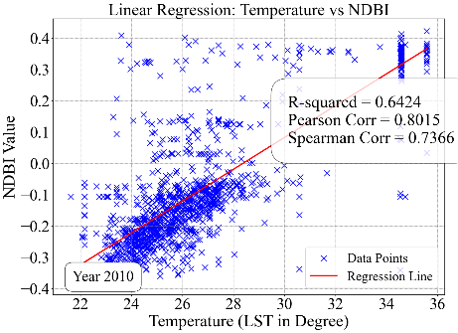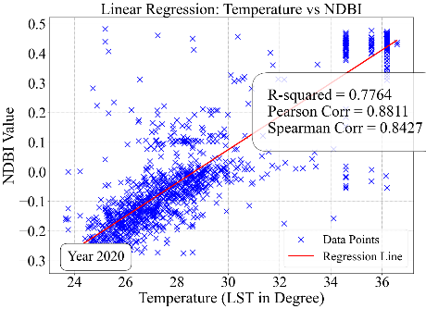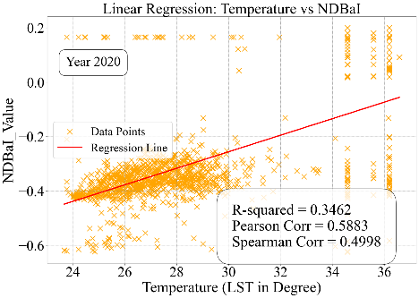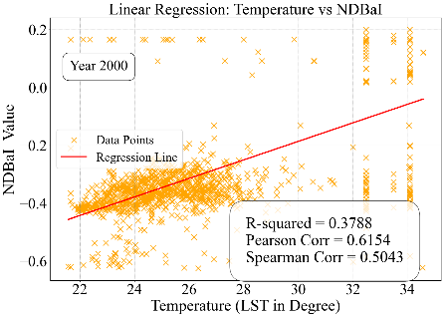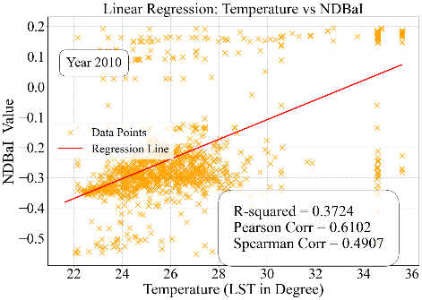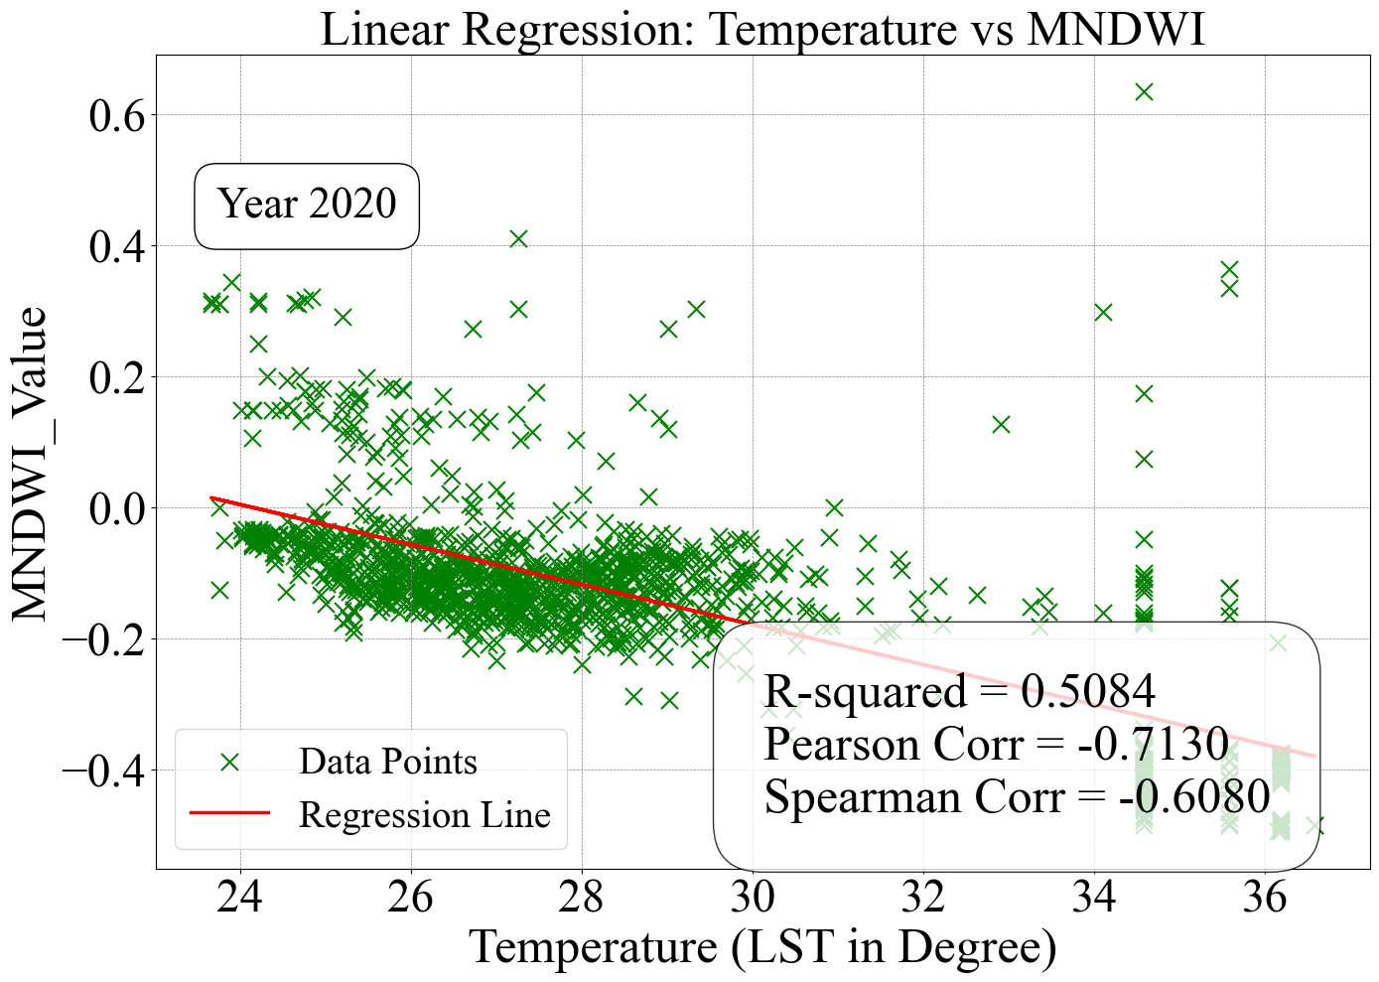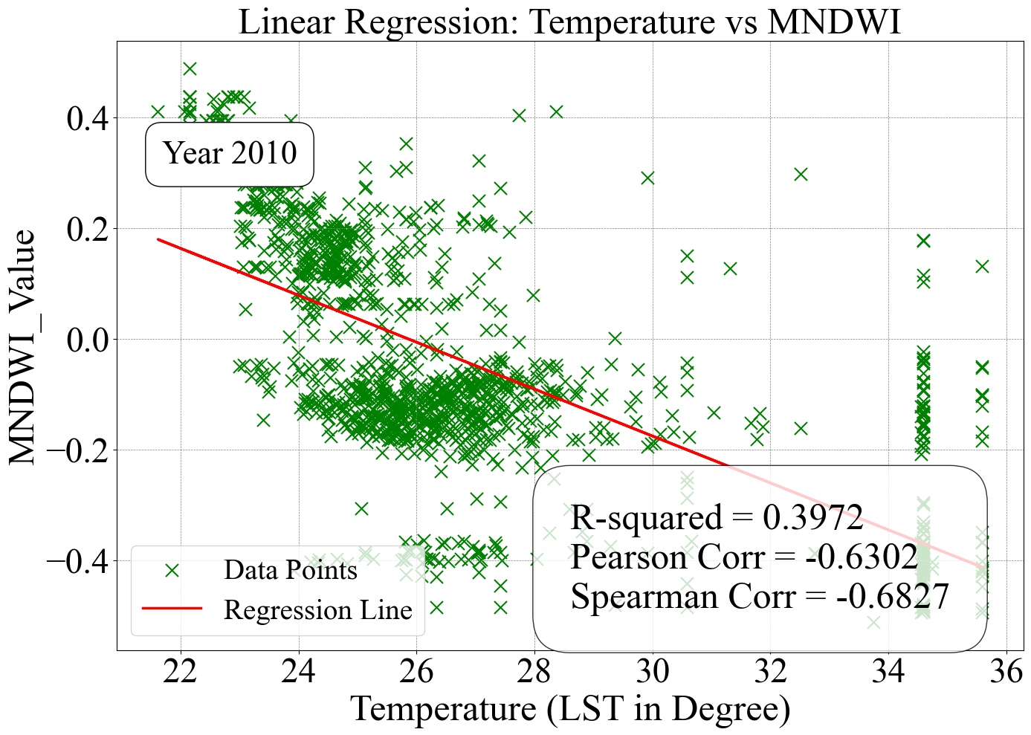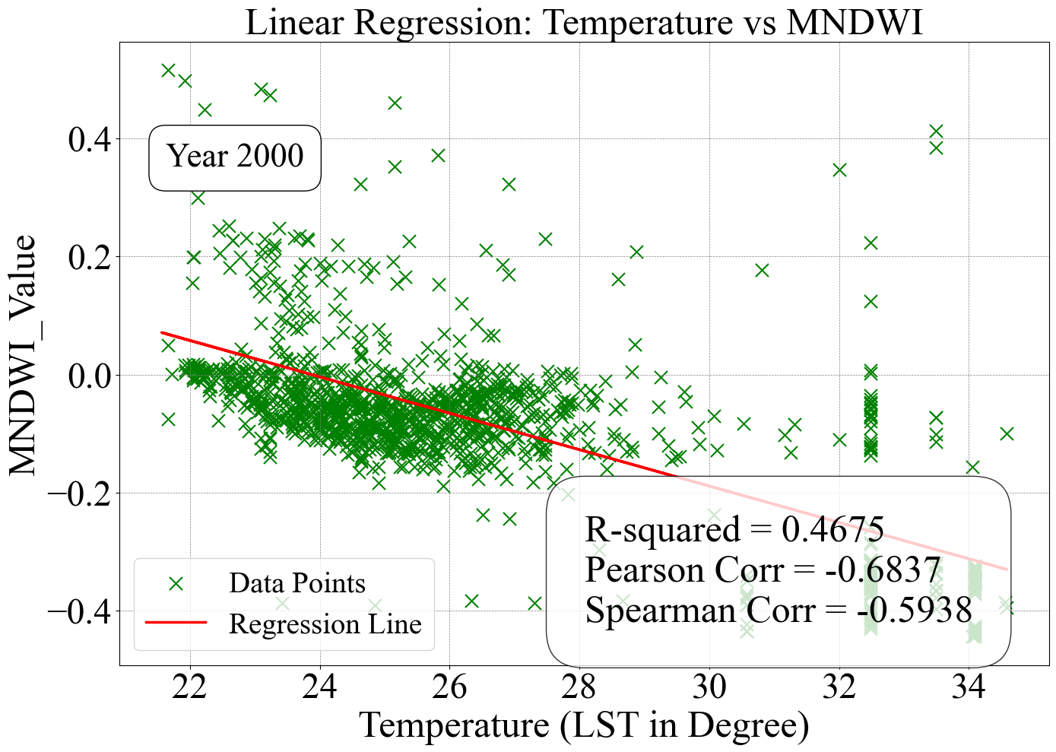

Fig. 10 shows that all the land cover dynamics have significant influences on the LST dynamics during the winter season. The Spearman coefficient values -0.5005, -0.4540 and -0.4640 (Pearson’s r = -0.5196, -0.450, -0.4944) for the years 2000, 2010 and 2020 indicate moderate negative correlations between MNDWI and LST dynamics. The correlation coefficient between NDVI and LST also indicates strong negative influences on LST dynamics. The positive correlations between the NDBAI and LST (Pearson’s r = +0.4643, +0.4899 and +0.47701) indicate that the increase of bare lands has been accelerating the surface temperature of Dhaka. Transformations of AL and VG to bare lands decrease the soil's heat absorption capacity and thus increase the surface temperature. On the other hand, the increase of the built-up areas helped to accelerate the average LST of Dhaka district significantly. This is reflected in the association between NDBI and LST. The R2 value between both seasons’ NDBI and LST shows the positive significant influences of the built-up expansions on the rise of LST in the study area.

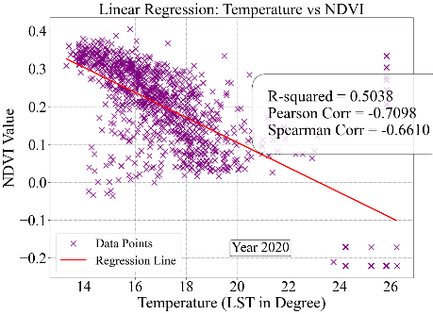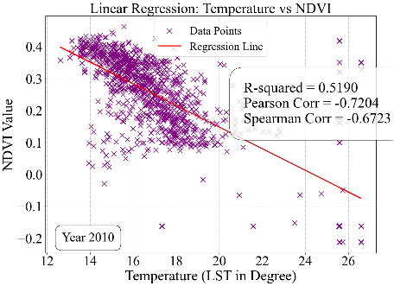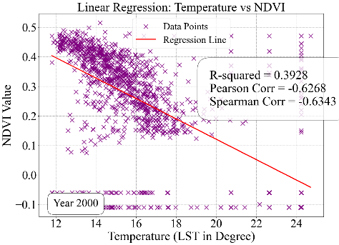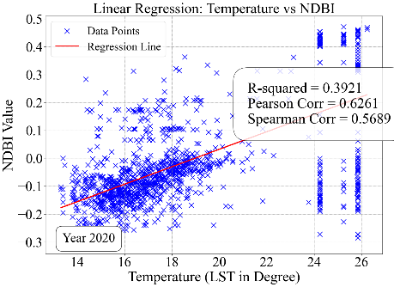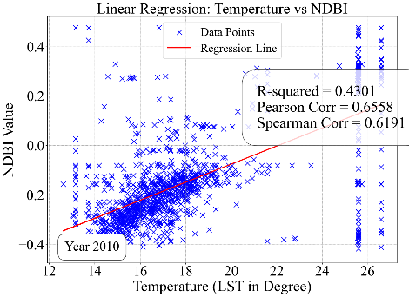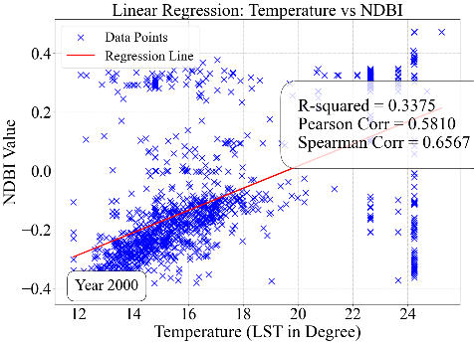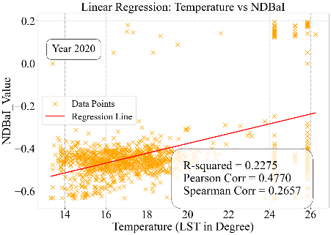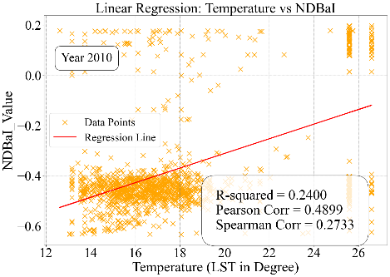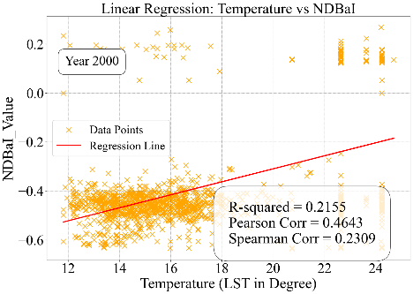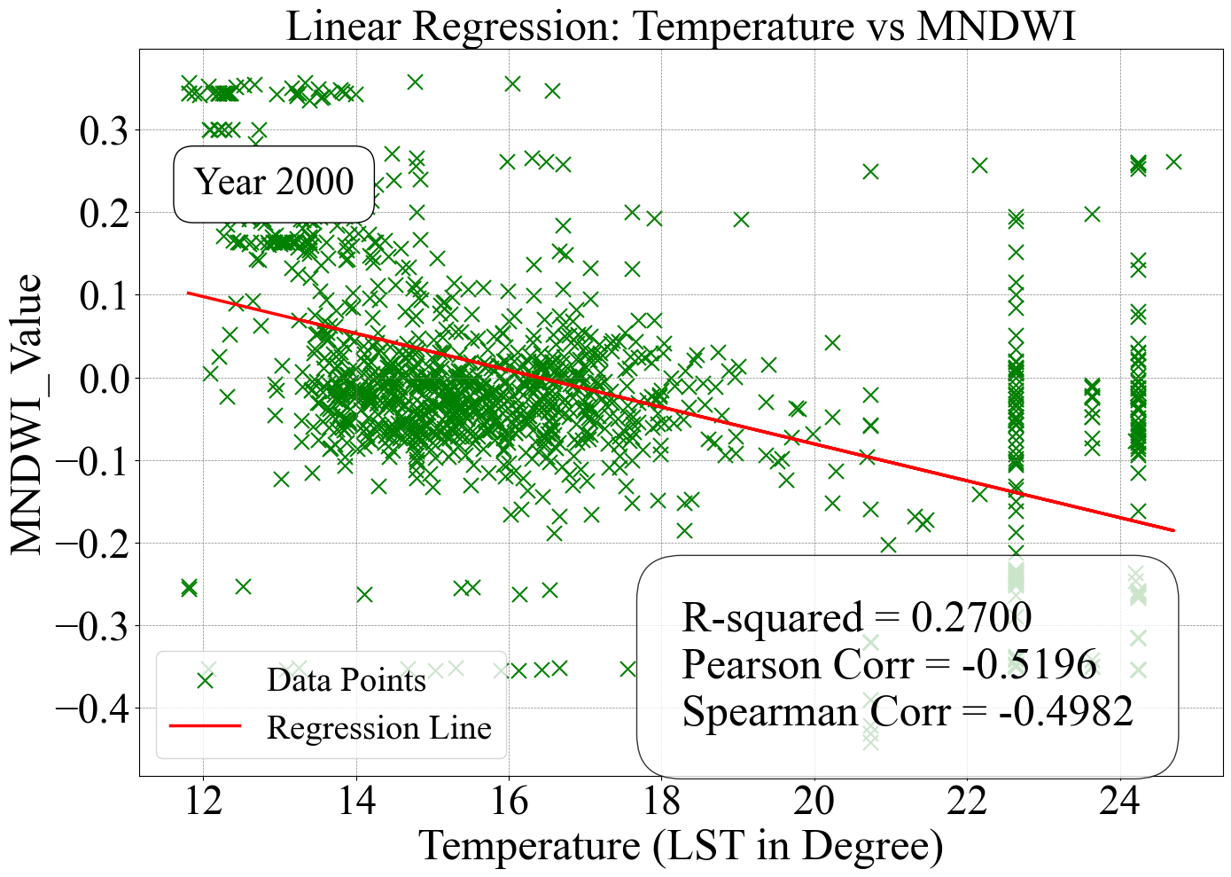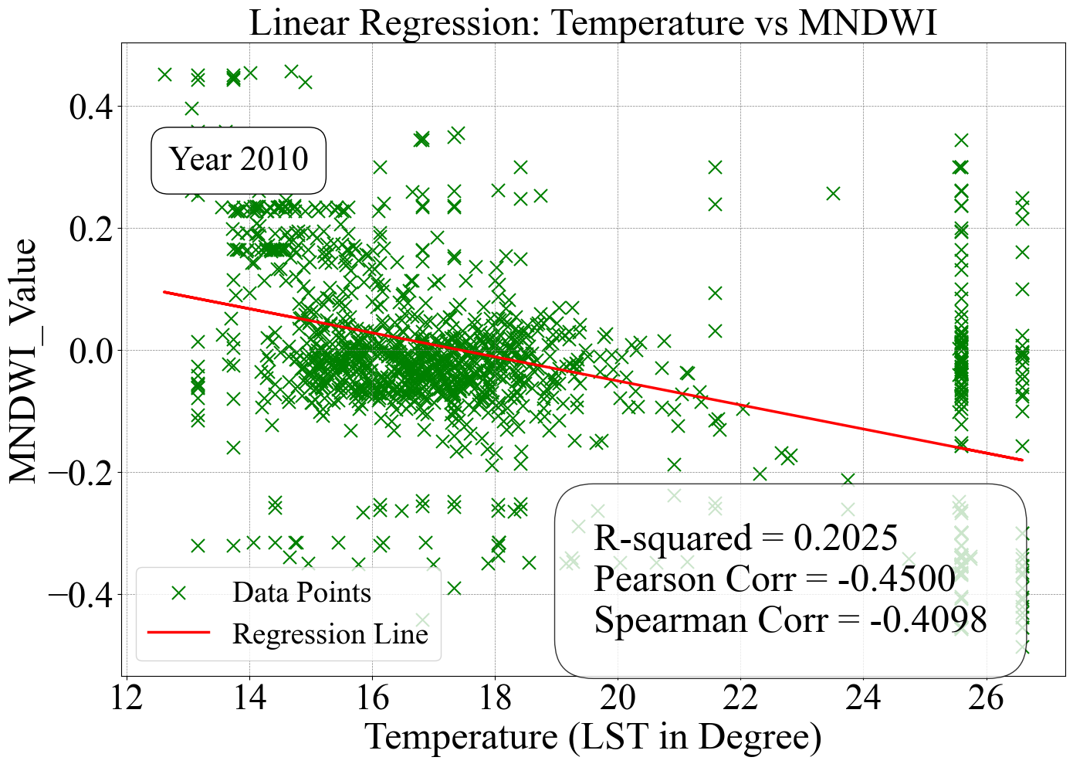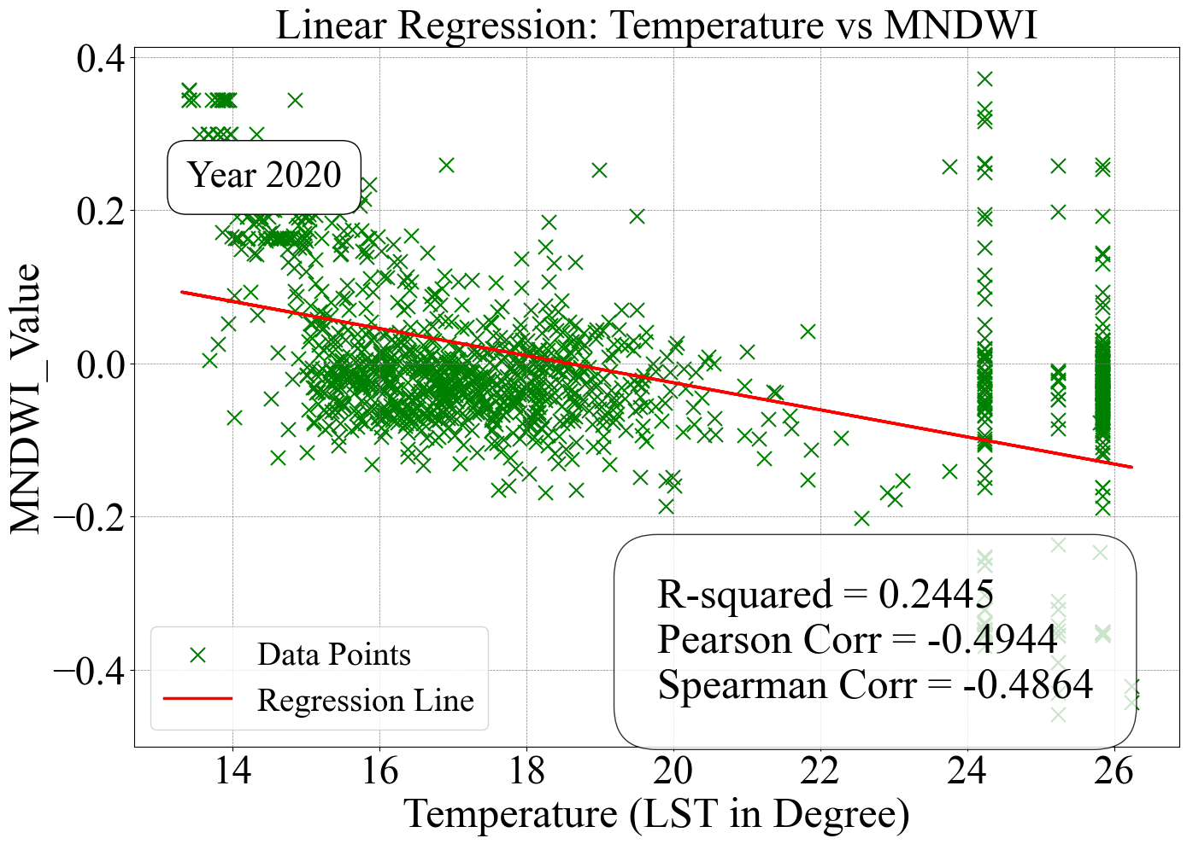

**Fig. 10.** Correlation between the winter season land use indices and LST during 2000–2020

**Discussion and Conclusion**

This study highlights the significant role of land use and land cover (LULC) changes, particularly the increase in built-up areas and the decrease in vegetation cover, in driving land surface temperature (LST) dynamics in Dhaka District, Bangladesh, from 2000 to 2020. Seasonal LULC and LST variations were analyzed using four indices: MNDWI, NDVI, NDBAI, and NDBI. Built-up areas expanded by 126.32 km², replacing 96.80 km² of agricultural land and 63.20 km² of vegetation, with more rapid growth observed in suburban areas compared to Dhaka city. This urban expansion contributed to a rise in mean LST by 3.07°C in summer and 1.89°C in winter. Over the study period, areas with higher summer LST (35°C–40°C) increased from 12.5% to 36.5%, while areas with the lowest LST (15°C–20°C) declined from 61.48% to 42.6%. The analysis revealed that MNDWI and NDVI were inversely correlated with LST, whereas NDBI and NDBAI showed positive correlations, identifying vegetation decline as the primary factor driving LST increases.

Although this study relied on freely available satellite imagery, it provides a low-cost and efficient approach for continuous monitoring of LULC and LST changes. However, the limitations of low-resolution data and inaccuracies in detecting certain changes, such as waterbody fluctuations, should be addressed in future research by incorporating higher-resolution imagery. Despite these limitations, the study offers valuable insights for sustainable urban planning. Its findings emphasize the need to mitigate LST hotspots and maintain ecological balance through strategic urban development and vegetation conservation. The study’s approach and results contribute to the broader discourse on urban heat mitigation, equipping land use planners and policymakers with the tools to monitor seasonal LULC and LST dynamics and guide targeted cooling and land management strategies.

**References**

Ahmed, B., Kamruzzaman, Md., Zhu, X., Rahman, Md., & Choi, K. (2013). Simulating Land Cover Changes and Their Impacts on Land Surface Temperature in Dhaka, Bangladesh. *Remote Sensing*, *5*(11), 5969–5998. https://doi.org/10.3390/rs5115969

Arefin, R. (2020). Groundwater potential zone identification at Plio-Pleistocene elevated tract, Bangladesh: AHP-GIS and remote sensing approach. *Groundwater for Sustainable Development*, *10*, 100340. https://doi.org/10.1016/j.gsd.2020.100340

Chen, X.-L., Zhao, H.-M., Li, P.-X., & Yin, Z.-Y. (2006). Remote sensing image-based analysis of the relationship between urban heat island and land use/cover changes. *Remote Sensing of Environment*, *104*(2), 133–146. https://doi.org/10.1016/j.rse.2005.11.016

Das, N., Mondal, P., Sutradhar, S., & Ghosh, R. (2021). Assessment of variation of land use/land cover and its impact on land surface temperature of Asansol subdivision. *The Egyptian Journal of Remote Sensing and Space Science*, *24*(1), 131–149. https://doi.org/10.1016/j.ejrs.2020.05.001

Grigoraș, G., & Urițescu, B. (2019). Land Use/Land Cover changes dynamics and their effects on Surface Urban Heat Island in Bucharest, Romania. *International Journal of Applied Earth Observation and Geoinformation*, *80*, 115–126. https://doi.org/10.1016/j.jag.2019.03.009

Huang, G., & Cadenasso, M. L. (2016). People, landscape, and urban heat island: Dynamics among neighborhood social conditions, land cover and surface temperatures. *Landscape Ecology*, *31*(10), 2507–2515. https://doi.org/10.1007/s10980-016-0437-z

Isaac, E. (2018). *Test for Significance of Pearson’s Correlation Coefficient ()*.

Kumar, M., Mondal, I., & Pham, Q. B. (2021). Monitoring forest landcover changes in the Eastern Sundarban of Bangladesh from 1989 to 2019. *Acta Geophysica*, *69*(2), 561–577. https://doi.org/10.1007/s11600-021-00551-3

Lemonsu, A., Kounkou-Arnaud, R., Desplat, J., Salagnac, J.-L., & Masson, V. (2013). Evolution of the Parisian urban climate under a global changing climate. *Climatic Change*, *116*(3), 679–692. https://doi.org/10.1007/s10584-012-0521-6

Li, X., Zhou, Y., Asrar, G. R., Imhoff, M., & Li, X. (2017). The surface urban heat island response to urban expansion: A panel analysis for the conterminous United States. *Science of The Total Environment*, *605–606*, 426–435. https://doi.org/10.1016/j.scitotenv.2017.06.229

Lowe, S. A. (2016). An energy and mortality impact assessment of the urban heat island in the US. *Environmental Impact Assessment Review*, *56*, 139–144. https://doi.org/10.1016/j.eiar.2015.10.004

Ophra, S. J., Begum, S., Islam, R., & Islam, Md. N. (2018). Assessment of bank erosion and channel shifting of Padma River in Bangladesh using RS and GIS techniques. *Spatial Information Research*, *26*(6), 599–605. https://doi.org/10.1007/s41324-018-0202-2

Steeneveld, G.-J., Klompmaker, J. O., Groen, R. J. A., & Holtslag, A. A. M. (2018). An urban climate assessment and management tool for combined heat and air quality judgements at neighbourhood scales. *Resources, Conservation and Recycling*, *132*, 204–217. https://doi.org/10.1016/j.resconrec.2016.12.002

Thakur, S., Maity, D., Mondal, I., Basumatary, G., Ghosh, P. B., Das, P., & De, T. K. (2021). Assessment of changes in land use, land cover, and land surface temperature in the mangrove forest of Sundarbans, northeast coast of India. *Environment, Development and Sustainability*, *23*(2), 1917–1943. https://doi.org/10.1007/s10668-020-00656-7

Thakur, S., Mondal, I., Bar, S., Nandi, S., Ghosh, P. B., Das, P., & De, T. K. (2021). Shoreline changes and its impact on the mangrove ecosystems of some islands of Indian Sundarbans, North-East coast of India. *Journal of Cleaner Production*, *284*, 124764. https://doi.org/10.1016/j.jclepro.2020.124764

Zhang, F., Tiyip, T., Kung, H., Johnson, V. C., Maimaitiyiming, M., Zhou, M., & Wang, J. (2016). Dynamics of land surface temperature (LST) in response to land use and land cover (LULC) changes in the Weigan and Kuqa river oasis, Xinjiang, China. *Arabian Journal of Geosciences*, *9*(7), 499. https://doi.org/10.1007/s12517-016-2521-8

**GitHub Link for Analysis Code**

<https://github.com/chsharrison/Sci_comp_F24/blob/main/Sharmin_Siddika/Week14_research_notebook.ipynb>